LECTURE 1+2
INTRODUCTION

Security?
Meaning
Security means protection from danger, risk, or harm.
In computing, security means protecting systems, data, and users from misuse or attacks.
Security is needed because:
- Computers store important data
- Systems are connected to networks and the internet
- Attackers try to misuse systems intentionally
Simple Idea
Security = Keeping bad things from happening to systems and data
Technical Example
- A password on your laptop
  - Prevents unauthorized users from opening your system
  - This is a basic form of security

Security: Computer / Network / Information / Internet
Security in IT is divided based on what exactly we are trying to protect. Each type focuses on a different layer of the system.
1. Computer Security
Definition
Computer security is the protection of a single computer system and its resources from unauthorized access, damage, or misuse.
It protects:
- Hardware (CPU, disk, memory)
- Software (OS, applications)
- Data stored on the system
Main Goals
- Prevent unauthorized users
- Protect system files and programs
- Ensure the system works correctly
What Threats Look Like
- Viruses and malware
- Unauthorized login
- File deletion or modification
Technical Example
- Antivirus software
  - Scans files for malicious code
  - Stops malware from corrupting the OS
- User login accounts
  - Only authorized users can access the system
📌 Example scenario:
If a virus deletes system files on your laptop → computer security has failed.
2. Network Security
Definition
Network security protects data and systems while they are connected through a network.
It focuses on:
- Data during transmission
- Network devices (routers, switches)
- Preventing unauthorized access
Main Goals
- Stop intruders from entering the network
- Protect data moving between devices
- Monitor network traffic
What Threats Look Like
- Packet sniffing
- Man-in-the-middle attacks
- Unauthorized device access
Technical Example
- Firewall
  - Filters incoming and outgoing traffic
  - Blocks suspicious connections
- Intrusion Detection System (IDS)
  - Detects abnormal network activity
📌 Example scenario:
If a hacker captures your data while it is being sent over Wi-Fi → network security has failed.
3. Information Security
Definition
Information security is the protection of information in any form, whether:
- Digital (files, databases)
- Physical (printed documents)
It ensures information is:
- Confidential
- Accurate
- Available when needed
Main Focus
Protect information from:
- Unauthorized access
- Modification
- Destruction
What Threats Look Like
- Data theft
- Data tampering
- Accidental data loss
Technical Example
- Data encryption
  - Converts readable data into unreadable form
- Access control
  - Only authorized users can view or modify information
📌 Example scenario:
If someone edits exam records in a database without permission → information security is broken.
4. Internet Security
Definition
Internet security focuses on protecting systems and data specifically exposed to the internet.
It deals with:
- Online threats
- Web-based attacks
- Internet communications
Main Goals
- Secure online transactions
- Protect user privacy
- Prevent web attacks
What Threats Look Like
- Phishing attacks
- Website hacking
- Malware from downloads
Technical Example
- HTTPS (SSL/TLS)
  - Encrypts data sent between browser and server
- Web application firewall
  - Protects websites from attacks like SQL injection
📌 Example scenario:
If your login details are stolen from a fake website → internet security has failed.

What is “Security”
Concept (System Correctness vs Security)
System Correctness
- System behaves correctly when normal users give valid input
Security
- System behaves safely even when attackers give malicious or unexpected input
Key Difference
- Correctness → assumes good users
- Security → assumes attackers exist
Technical Example
- Login system
  - Correctness: Accepts valid username & password
  - Security: Prevents SQL injection like => ' OR '1'='1
  - Even with bad input, system must not break
Information Security Goals: CIA Triad
The CIA Triad represents the three main goals of Information Security.
Every security system is designed to protect these three things.
CIA stands for:
- Confidentiality
- Integrity
- Availability
These goals apply to:
- Computer Security
- Network Security
- Information Security
- Cyber Security
1. Confidentiality
Definition
Confidentiality means information should only be accessible to authorized users.
Unauthorized users must not read the data.
What it protects against
- Data leakage
- Eavesdropping
- Unauthorized access
Technical Example
- Password-protected email account
  - Only the owner can read emails
- Encryption
  - Even if data is stolen, it remains unreadable
📌 Example scenario:
If a hacker reads your bank details → confidentiality is broken.
2. Integrity
Definition
Integrity means information must remain accurate, complete, and unaltered.
Data should not be changed without permission.
What it protects against
- Data modification
- Tampering
- False data injection
Technical Example
- Hash functions
  - Detect whether data has been altered
- Digital signatures
  - Verify data authenticity
📌 Example scenario:
If someone changes marks in a university database → integrity is broken.
3. Availability
Definition
Availability means authorized users can access information and systems when needed.
System should not be unavailable due to attacks or failures.
What it protects against
- System downtime
- Denial of Service (DoS) attacks
- Hardware failures
Technical Example
- Backup servers
  - Ensure system is available if main server fails
- UPS (Uninterruptible Power Supply)
  - Keeps systems running during power failure
📌 Example scenario:
If a website crashes during online registration → availability is broken.
Simple Memory Line (Exam Tip)
Confidentiality = Who can see data
Integrity = Can data be trusted
Availability = Can data be accessed

Security Terminology
1. Adversary (Threat Agent)
Detailed Explanation
An adversary (also called a threat agent) is the entity that has the intention and capability to cause harm to a system.
It is not the attack itself—it is who performs the attack.
An adversary can be:
- Human (hacker, insider, criminal)
- Non-human (malicious software acting automatically)
Key Characteristics
- Has motivation (money, revenge, curiosity)
- Has skills or tools
- Actively tries to bypass security
Proper Technical Example
A hacker targets a university server to steal student records.
➡ The hacker is the adversary.
2. Threat
Detailed Explanation
A threat is a potential danger that could exploit a system and cause damage.
It exists even if no attack happens yet.
A threat depends on:
- The existence of valuable assets
- The presence of vulnerabilities
Key Characteristics
- It is a possibility, not an action
- Becomes serious when vulnerabilities exist
Proper Technical Example
The possibility of hacking a poorly secured website is a threat.
➡ No hacking has happened yet, but the danger exists.
3. Vulnerability
Detailed Explanation
A vulnerability is a weakness or flaw in the system’s design, implementation, or operation that can be exploited.
Without vulnerabilities:
- Threats cannot turn into attacks
Key Characteristics
- Can be technical or human
- Often caused by poor design or misconfiguration
Proper Technical Example
- Weak password like admin123
- Unpatched operating system
➡ These weaknesses are vulnerabilities.
4. Attack
Detailed Explanation
An attack is a deliberate and intelligent action performed by an adversary to exploit a vulnerability and violate security rules.
It is the execution stage of a threat.
Key Characteristics
- Always intentional
- Uses a method or technique
Proper Technical Example
A hacker performs a SQL injection to access a database.
➡ This action is an attack.
5. System Resource (Asset)
Detailed Explanation
An asset is anything valuable that needs protection in a system.
Security exists only to protect assets.
Assets can be:
- Data
- Services
- Hardware
- Capabilities
Proper Technical Example
- Student records database
- Online banking service
- Server hardware
➡ These are assets.
6. Risk
Detailed Explanation
Risk is the expected loss or damage that may occur when a threat successfully exploits a vulnerability and harms an asset.
Risk considers:
- Likelihood of attack
- Severity of impact
Key Characteristics
- Risk is not absolute
- It is measured, not eliminated
Proper Technical Example
- Weak passwords + public server + sensitive data
➡ High risk of data breach.
7. Countermeasure (Security Control)
Detailed Explanation
A countermeasure is a technical or procedural method used to:
- Prevent attacks
- Detect attacks
- Minimize damage
Countermeasures reduce risk, they do not remove all threats.
Types
- Preventive
- Detective
- Corrective
Proper Technical Example
- Firewall blocks unauthorized access
- Encryption protects stolen data
➡ These are countermeasures.
8. Security Policy
Detailed Explanation
A security policy is a formal document or rule set that defines how security must be implemented and enforced.
It tells:
- What is allowed
- What is forbidden
- How systems should be protected
Key Characteristics
- High-level
- Mandatory
- Enforced by countermeasures
Proper Technical Example
- “Passwords must be at least 12 characters long”
- “Only admins can access the database”
➡ These rules form a security policy.

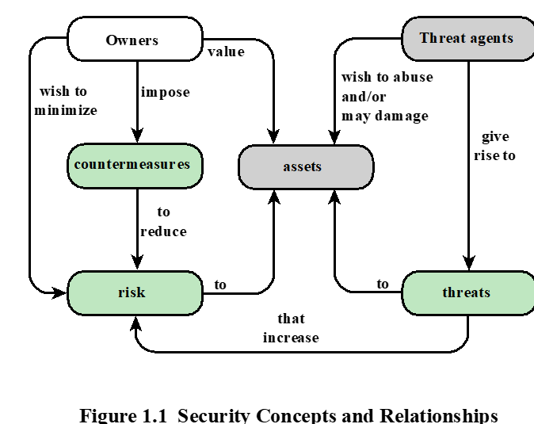

Explanation:
The flow starts with owners. Owners are the people or organizations that own systems and data. They value certain things, such as databases, servers, services, or information. Because these things are valuable, they are called assets.
At the same time, there exist threat agents (such as hackers, insiders, or malware). These threat agents wish to abuse or damage the assets. Because threat agents exist, they give rise to threats. A threat is the possibility that an asset may be harmed.
These threats increase the risk to the assets. Risk represents the chance of loss or damage to valuable assets due to threats. The more valuable the asset and the more active the threat agents, the higher the risk becomes.
Since owners do not want to lose their assets, they wish to minimize risk. To do this, owners impose countermeasures such as firewalls, access control, encryption, policies, and monitoring systems.
These countermeasures act on the system to reduce risk. They do not remove threat agents completely, but they lower the probability of successful attacks or reduce the damage caused if an attack happens.
The reduced risk then feeds back to the assets, making them safer and more protected, even though threats still exist. This creates a continuous cycle: assets remain valuable, threats continue to exist, risk is constantly evaluated, and countermeasures are continuously applied and improved.

Why are there security vulnerabilities?
Security vulnerabilities exist because software and systems are created by humans, and humans make mistakes. Many systems are designed to work correctly, not securely, which creates weaknesses.
Main reasons:
- Buggy software: Programming errors create loopholes attackers can exploit.
- Lack of security awareness: Many programmers focus on functionality, not security.
- Complex systems: Large systems are difficult to fully test.
- Unsafe programming languages: Languages like C/C++ allow memory errors.
- Legacy software: Old systems were not designed for modern threats.
- Cost and time pressure: Security increases development time and cost.
- Users ignore security: Weak passwords, careless behavior.
👉 Important idea:
If a vulnerability exists, it will eventually be found and exploited.
Example:
A web application does not validate user input properly → SQL injection vulnerability.

Vulnerabilities, Threats, and Attacks
These three terms are closely related but different.
- Vulnerability: A weakness in the system
- Threat: A potential danger that can exploit the weakness
- Attack: The actual action that exploits the weakness
Flow:
Vulnerability → Threat → Attack
Example:
- Vulnerability: Weak password
- Threat: Hacker trying to gain access
- Attack: Brute-force login attempt

Categories of Vulnerabilities
Vulnerabilities are categorized based on which CIA security goal they affect.
- Corrupted (Loss of Integrity)
Data can be altered without authorization.
Example:
Marks in a database are changed illegally.
- Leaky (Loss of Confidentiality)
Information is disclosed to unauthorized users.
Example:
Passwords stored in plain text are leaked.
- Unavailable or Very Slow (Loss of Availability)
System or data cannot be accessed when needed.
Example:
Website crashes during online registration.
Threats
A threat is a possible cause of security violation.
It represents potential harm, not an action.
Key points:
- Exists even if no attack happens
- Becomes dangerous when vulnerabilities exist
- Targets assets
Example:
The presence of hackers on the internet is a threat to online systems.
Attacks
An attack is the realization of a threat.
It is an intentional action that tries to violate security.
Key points:
- Always deliberate
- Exploits vulnerabilities
- Causes actual damage
Example:
A hacker launches SQL injection on a website → this is an attack.

Types of Attacks
Attacks are classified based on what they do and who performs them.
  - Passive Attacks
Passive attacks do not change system data.
The attacker only observes or collects information.
Goal:
- Steal information secretly
Difficult to detect.
Examples:
- Eavesdropping on network traffic
- Packet sniffing
- Monitoring unencrypted communication
👉 Affects Confidentiality
  - Active Attacks
Active attacks modify system resources or operations.
Goal:
- Damage system
- Alter data
- Disrupt services
Easier to detect than passive attacks.
Examples:
- Data modification
- Denial of Service (DoS)
- Website defacement
👉 Affects Integrity and Availability
  - Insider Attacks
Insider attacks are initiated by someone inside the organization.
Why dangerous:
- Insider already has access
- Knows system structure
Examples:
- Employee stealing customer data
- Admin misusing privileges
👉 Very hard to detect and prevent
  - Outsider Attacks
Outsider attacks are launched by external entities.
Characteristics:
- No authorized access
- Use hacking techniques to break in
Examples:
- Hacker attacking a public website
- Malware from the internet
👉 Easier to detect using firewalls and IDS

Threat Consequences and Their Threat Actions
The table groups attacks by what damage they cause (threat consequence) and then lists how that damage happens (threat actions).
1. Unauthorized Disclosure
(Loss of Confidentiality)
This happens when information is revealed to someone who is not allowed to see it.
a) Exposure
Meaning:
Sensitive data is directly released to an unauthorized person.
Example:
A company accidentally uploads an Excel file containing employee salaries to a public website.
➡ Data is openly visible → Exposure
b) Interception
Meaning:
An unauthorized entity captures data while it is being transmitted.
Example:
A hacker uses packet sniffing on public Wi-Fi to capture unencrypted login credentials.
➡ Data was intercepted during transmission → Interception
c) Inference
Meaning:
Sensitive information is indirectly guessed by analyzing communication patterns, not the actual content.
Example:
An attacker notices frequent encrypted messages sent from a military base and infers that an operation is underway, even without decrypting messages.
➡ Information deduced indirectly → Inference
d) Intrusion
Meaning:
An attacker bypasses security controls to access sensitive data.
Example:
A hacker exploits a vulnerability to access a restricted database without permission.
➡ Security controls bypassed → Intrusion

2. Deception
(Loss of Integrity / Trust)
This happens when false information is accepted as true.
a) Masquerade
Meaning:
An attacker pretends to be a legitimate user.
Example:
An attacker logs in using stolen credentials and sends emails pretending to be the company manager.
➡ Fake identity → Masquerade
b) Falsification
Meaning:
False data is inserted or modified to deceive users.
Example:
An attacker alters transaction records to show extra money credited to an account.
➡ Data changed falsely → Falsification
c) Repudiation
Meaning:
An entity denies performing an action that it actually did.
Example:
A user transfers money online and later claims, “I never made this transaction.”
➡ Denial of responsibility → Repudiation

3. Disruption
(Loss of Availability / Correct Operation)
This happens when system services are interrupted or degraded.
a) Incapacitation
Meaning:
A system or component is completely disabled.
Example:
A server is shut down by malware, making a website completely unavailable.
➡ System disabled → Incapacitation
b) Corruption
Meaning:
System data or functions are modified in an undesirable way.
Example:
A virus corrupts system files, causing applications to crash frequently.
➡ System behavior altered → Corruption
c) Obstruction
Meaning:
System services are delayed or blocked, but not destroyed.
Example:
A Distributed Denial of Service (DDoS) attack floods a server with traffic, slowing it down.
➡ Service delivery hindered → Obstruction

4. Usurpation
(Loss of Control)
This happens when an unauthorized entity takes control of system resources.
a) Misappropriation
Meaning:
An attacker takes unauthorized control of system resources.
Example:
An attacker gains admin access and controls a server remotely.
➡ Control stolen → Misappropriation
b) Misuse
Meaning:
A system is used in a harmful way, even if it works correctly.
Example:
A compromised server is used to send spam emails or mine cryptocurrency.
➡ System used for harmful purpose → Misuse

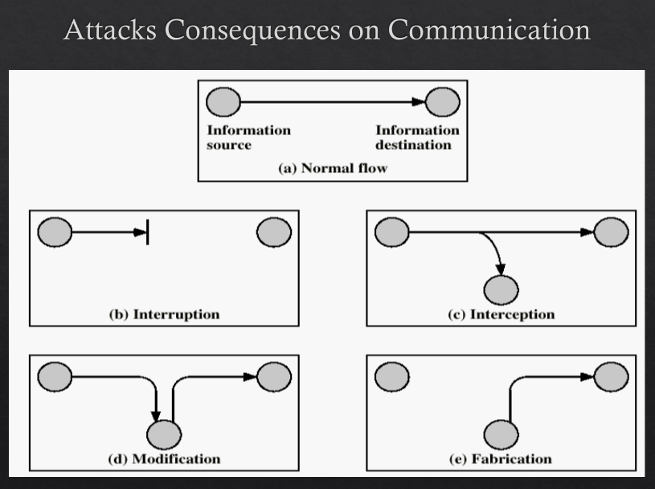
Attacks Consequences on Communication
(a) Normal Flow
This is the ideal situation.
Information flows directly from the information source to the information destination without any interference.
- Data is correct
- Data reaches on time
- No one else sees it
👉 No security goal is violated
Example:
You send an email to your friend and they receive the exact message.
(b) Interruption
Here, the communication is stopped or broken.
The message does not reach the destination.
This attack targets availability.
What happens:
- The sender sends data
- The connection is cut
- Receiver gets nothing
Example:
A Denial-of-Service (DoS) attack shuts down a server so users cannot access it.
👉 Availability is violated
(c) Interception
Here, the message still reaches the destination, but someone else secretly listens.
An unauthorized third party accesses the data during transmission.
This attack targets confidentiality.
What happens:
- Sender sends data
- Attacker copies the data
- Receiver still gets the message
Example:
A hacker sniffs unencrypted Wi-Fi traffic and reads login credentials.
👉 Confidentiality is violated
(d) Modification
Here, the message is changed while traveling to the destination.
The receiver gets altered or incorrect data.
This attack targets integrity.
What happens:
- Sender sends original data
- Attacker modifies it
- Receiver gets modified data
Example:
An attacker changes a bank transfer amount from 10,000 to 100,000 during transmission.
👉 Integrity is violated
(e) Fabrication
Here, fake data is sent to the destination without the sender’s involvement.
The receiver believes the message came from a legitimate source.
This attack targets integrity and authentication.
What happens:
- Attacker creates a fake message
- Sends it to the receiver
- Receiver accepts it as real
Example:
An attacker sends a fake email pretending to be the bank asking for login details.
👉 Integrity & Authentication are violated

Computer Security Model
The Computer Security Model explains how a computer system is protected from attacks and how security is applied inside a single system.
Core Idea (Big Picture)
A computer system has:
- Assets (data, programs, OS)
- Threats (malware, unauthorized users)
- Security controls to protect those assets
The model focuses on protecting the system from internal and external misuse.
How the Model Works (Flow)
- A user (legitimate or attacker) tries to access the system
- The system checks security controls (authentication, access control)
- Only authorized actions are allowed
- Unauthorized actions are blocked or logged
What it Protects
- Files
- Memory
- CPU
- Operating system
- Applications
Key Security Functions
- User authentication (login)
- Authorization (permissions)
- Auditing (logs)
- Malware protection
Technical Example
A laptop:
- User must log in with username/password
- OS enforces file permissions
- Antivirus scans programs before execution
Network Security Model
The Network Security Model explains how data is protected when it is transmitted over a network.
Data moves from: Sender → Network → Receiver
The network is not trusted, so security must protect data while it travels.
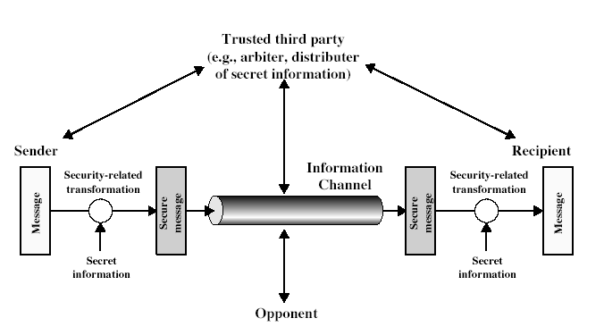
How the Model Works (Flow)
The Network Security Model explains how information is securely transmitted from a sender to a recipient over an insecure network in the presence of an attacker.
The process begins with the sender, who has an original message that needs to be transmitted securely. Since the communication channel (such as the Internet) is not trusted, the sender cannot send the message directly in plain form.
To protect the message, the sender applies a security-related transformation. This transformation may include encryption, message authentication, or digital signing. The transformation uses secret information, such as a cryptographic key. After this process, the original message is converted into a secure message.
The secure message is then transmitted through the information channel. This channel represents an insecure medium where an opponent (attacker) may exist. The opponent can attempt to intercept, modify, fabricate, or disrupt the communication. However, because the message is protected by cryptographic techniques, the attacker cannot successfully understand or alter the message.
In many systems, a trusted third party plays an important role. The trusted third party may act as a key distributor, certificate authority, or arbiter. Its responsibility is to securely distribute secret keys or verify identities so that both sender and recipient can trust each other and communicate securely.
When the secure message reaches the recipient, the recipient applies a corresponding security-related transformation, such as decryption or verification, using secret information. This process converts the secure message back into the original readable message.
As a result, secure communication is achieved even though the transmission takes place over an insecure network and in the presence of an attacker.
Main Focus: Protect data in transit and Prevent interception, modification, and impersonation
Security Services Used
- Encryption
- Authentication
- Integrity checks
- Key management
Technical Example
When a user accesses a website using HTTPS, the browser encrypts the data using cryptographic keys. The encrypted data travels over the Internet, where attackers may be present. A Certificate Authority acts as a trusted third party. The web server decrypts the data upon receipt and processes it securely.

Network Access Security Model
The Network Access Security Model focuses on who is allowed to access the network itself, not just the data.
Before communication happens:
User/device must prove identity and authorization
This model acts as a gatekeeper to the network.
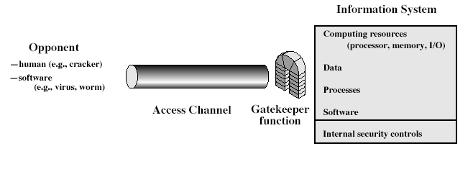
How the Model Works (Flow)
The flow starts with the opponent, which can be:
- A human attacker (for example, a hacker or cracker), or
- Malicious software (such as viruses, worms, or malware)
The opponent attempts to gain access to the system through the access channel. The access channel represents any network path such as the Internet, Wi-Fi, LAN, or remote login interface that connects external users to the system.
Before reaching the internal system, all access requests must pass through a gatekeeper function. The gatekeeper acts as the first line of defense. Its role is to:
- Authenticate users (verify identity)
- Authorize access (check permissions)
- Filter malicious traffic
Examples of gatekeeper mechanisms include firewalls, authentication servers, intrusion detection systems, VPN gateways, and access control mechanisms.
If access is allowed, the request reaches the Information System, which consists of:
- Computing resources (CPU, memory, input/output devices)
- Data (files, databases, records)
- Processes (running programs, system services)
- Software (applications and operating system)
Inside the information system, internal security controls operate continuously. These controls protect resources even after access is granted and include:
- Access control lists (ACLs)
- User permissions
- Process isolation
- Audit logs
- Malware detection
If the gatekeeper successfully blocks the opponent, the system remains secure. If the gatekeeper fails, internal security controls attempt to limit damage and prevent full system compromise.
Simple Technical Example
When a user connects to a company network:
- The Internet acts as the access channel
- Hackers and malware are opponents
- A firewall and login system act as the gatekeeper
- Company servers and databases are the information system
- User permissions and logging are internal security controls
Main Focus
- Prevent unauthorized network access
- Protect internal network resources
Security Techniques Used
- Passwords
- Digital certificates
- Biometric authentication
- Access control lists (ACLs)

Aspects of Information Security
Information security is commonly discussed using three main aspects:
- Security Attacks
- Security Services
- Security Mechanisms
These three aspects are closely related and together explain how information security works.
1. Security Attacks
Security attacks are actions that attempt to compromise the security of information or information systems.
An attack may attempt to:
- Access information without authorization
- Modify information
- Disrupt system services
Security attacks represent what the attacker does
They define the problem that information security must address
Examples:
- Eavesdropping on communication
- Modifying data during transmission
- Interrupting services (Denial of Service)
- Impersonating a legitimate user
2. Security Services
Security services are services provided to protect information and system resources against security attacks.
- Security services describe what type of protection is required
- They are designed to counter security attacks
Common security services include:
- Confidentiality – prevents unauthorized disclosure of information
- Integrity – ensures information is not altered improperly
- Authentication – verifies the identity of users or systems
- Access Control – restricts resource usage to authorized users
- Non-repudiation – prevents denial of performed actions
3. Security Mechanisms
Security mechanisms are the means used to implement security services.
- Security mechanisms describe how security services are achieved
- They are the tools and techniques used by the system
Commonly referenced security mechanisms include:
- Encryption techniques
- Digital signatures
- Access control mechanisms
- Authentication mechanisms
- Integrity checking mechanisms

Security Mechanisms
Security mechanisms are the methods and techniques used to implement security services.
They are designed to detect, prevent, or recover from security attacks.
X.800 defines security mechanisms that support one or more security services.
Common security mechanisms include:
- Encipherment (Encryption): Encipherment converts data into an unreadable form to prevent unauthorized access.
- Digital Signatures: Digital signatures are used to verify the sender’s identity and ensure data integrity.
- Access Control Mechanisms: Access control mechanisms restrict system resources to authorized users only.
- Message Authentication Codes (MAC): MACs are used to verify the integrity and authenticity of a message.
- Traffic Padding: Traffic padding adds extra data to hide communication patterns.
- Routing Control: Routing control selects secure paths for data transmission.

Security Services (X.800)
Security services are services defined by the X.800 (OSI Security Architecture) to provide protection for data and system resources.
According to X.800, a security service is a service provided by a protocol layer to ensure adequate security of systems or data transfers.
Main security services defined in X.800 are:
- Authentication – assures that the communicating entity is the one it claims to be
- Data Confidentiality – protects data from unauthorized disclosure
- Data Integrity – assures that data has not been altered during transmission or storage
- Access Control – prevents unauthorized use of system resources
- Non-repudiation – prevents denial of actions performed in communication

